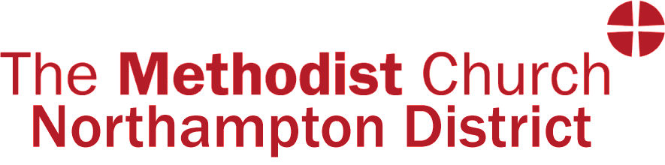

C*hair of District*  *Representative Synod Secretary*

The Rev’d Dr Sonia Hicks Paul Spray

August 2024

Dear friends,

We look forward to welcoming you at our Autumn Representative Synod on Saturday 7th September, at Brackley Methodist Church. Refreshments will be available from 9.30am; the session will start with a welcome and worship at 10.15am.

I attach various papers for the Synod, in the order that they will arise:

* The agenda.
* The proposed District Environmental Policy.
* The report of the District Executive.
* Three papers on the new constitution for Kingsthorpe LEP.
* Reasoned statements for five churches seeking to cease to meet.
* A pro forma that you can complete, if you wish Synod to send greetings to someone.

The Autumn Synod approves the appointment of all District officers. You will find these in the Directory on the District website.

A further paper will be sent out shortly, with details of candidates putting themselves forward as District representatives to the 2025 Methodist Conference. A ballot paper will be provided on the day, in hard copy and electronically.

If you are attending in person, please bring lunch. Tea and coffee will be provided.

Alternatively, if you cannot attend in person, the zoom link is   <https://zoom.us/j/91734453889?pwd=8ZofKDbUbVG6I498FU8oCVI0p7fb2N.1>  
Meeting ID: 917 3445 3889  
Passcode: 664949

Please email the office in advance, if possible, to let us know you will be on zoom.

Synod Secretary synod.secretary@northamptonmethodistdistrict.org.uk